Master node -> <http://localhost:9200/_cat/master> ->es03

Listener on 9200 -> es01

8.

**ES01, ES02, ES03**

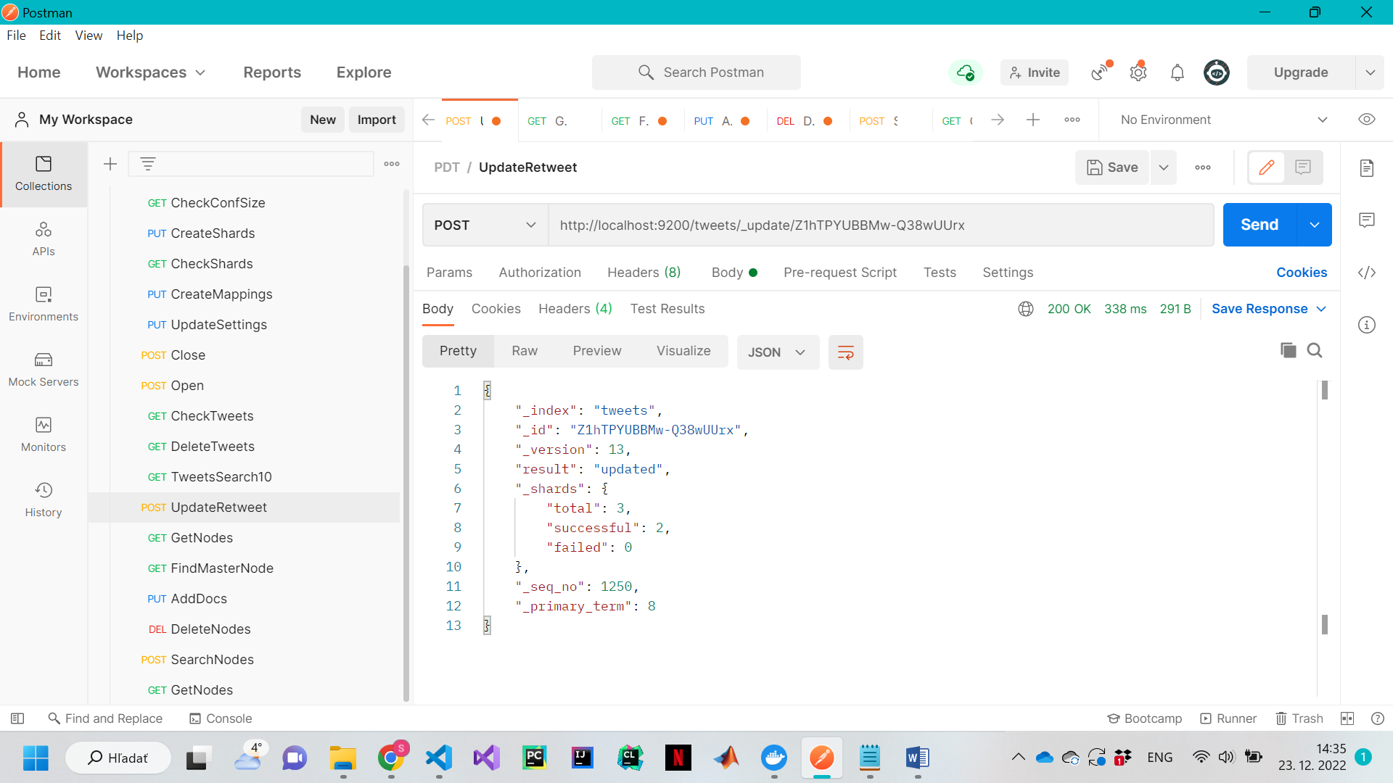

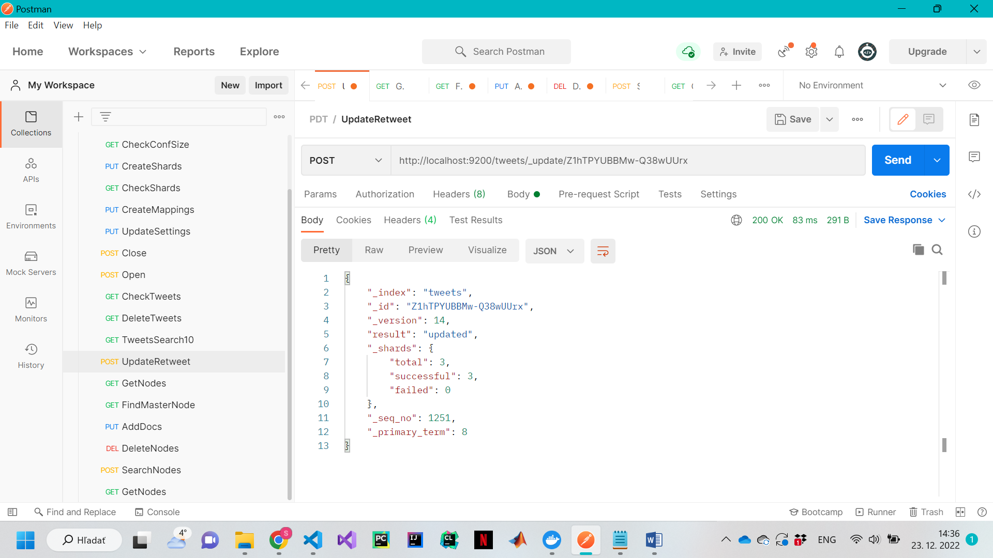

**ES02, ES03**

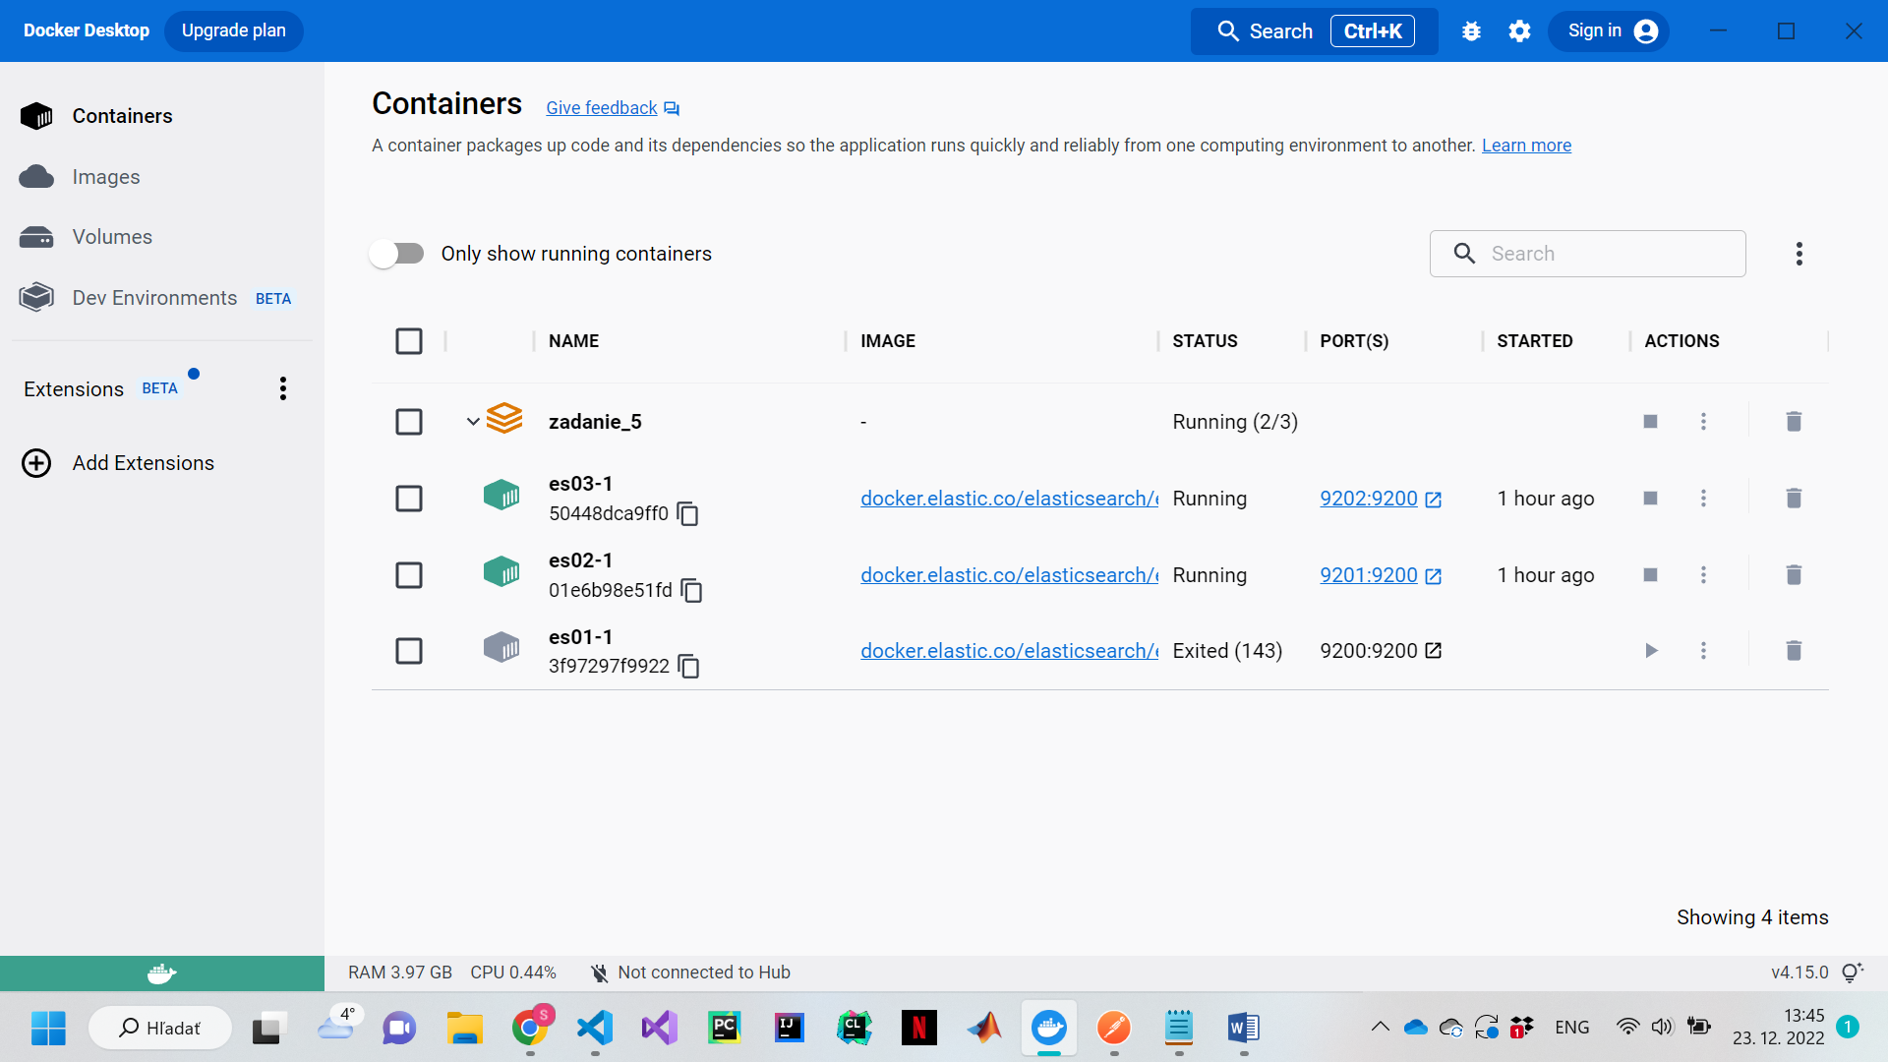

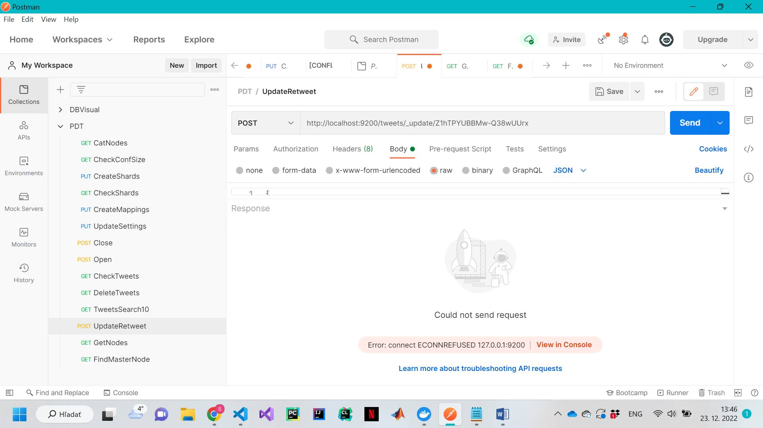

**ES01, ES02**

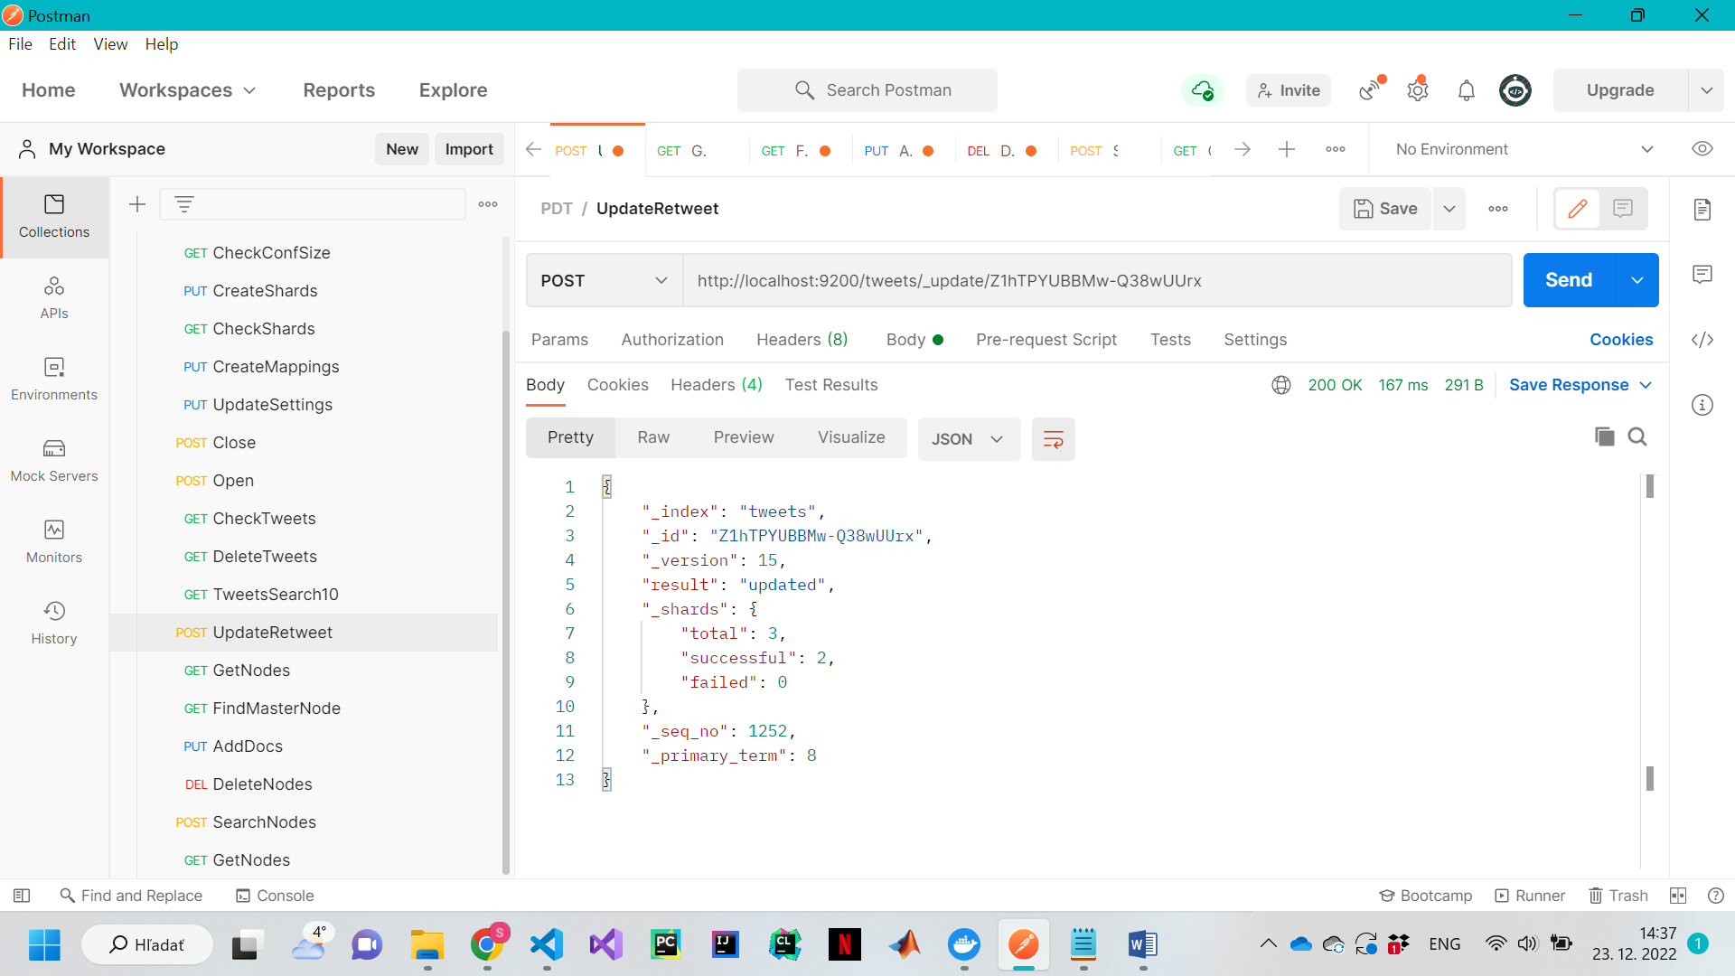

**ES01, ES03**

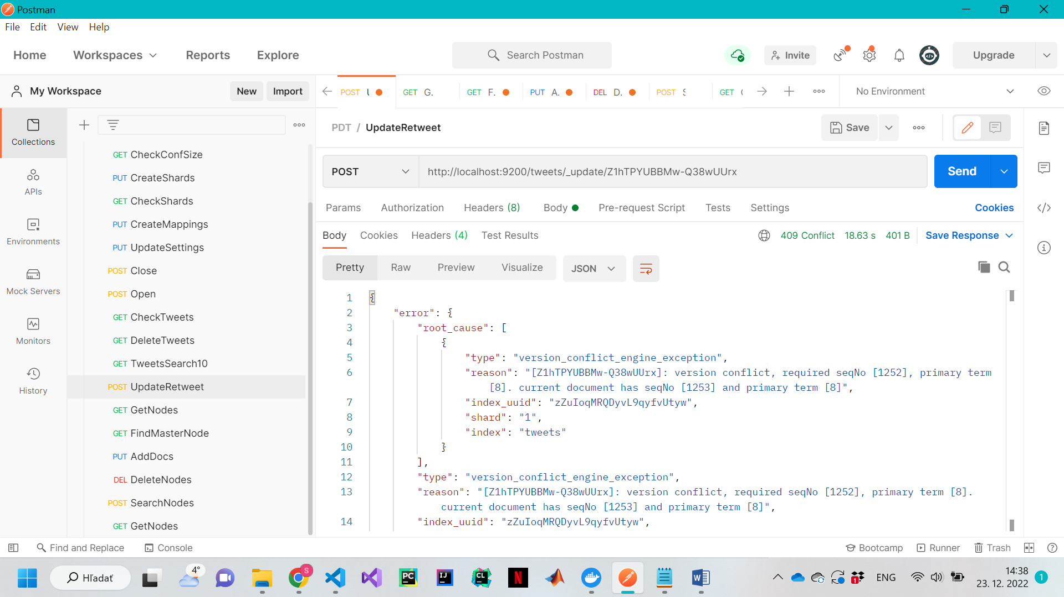

**Es01**

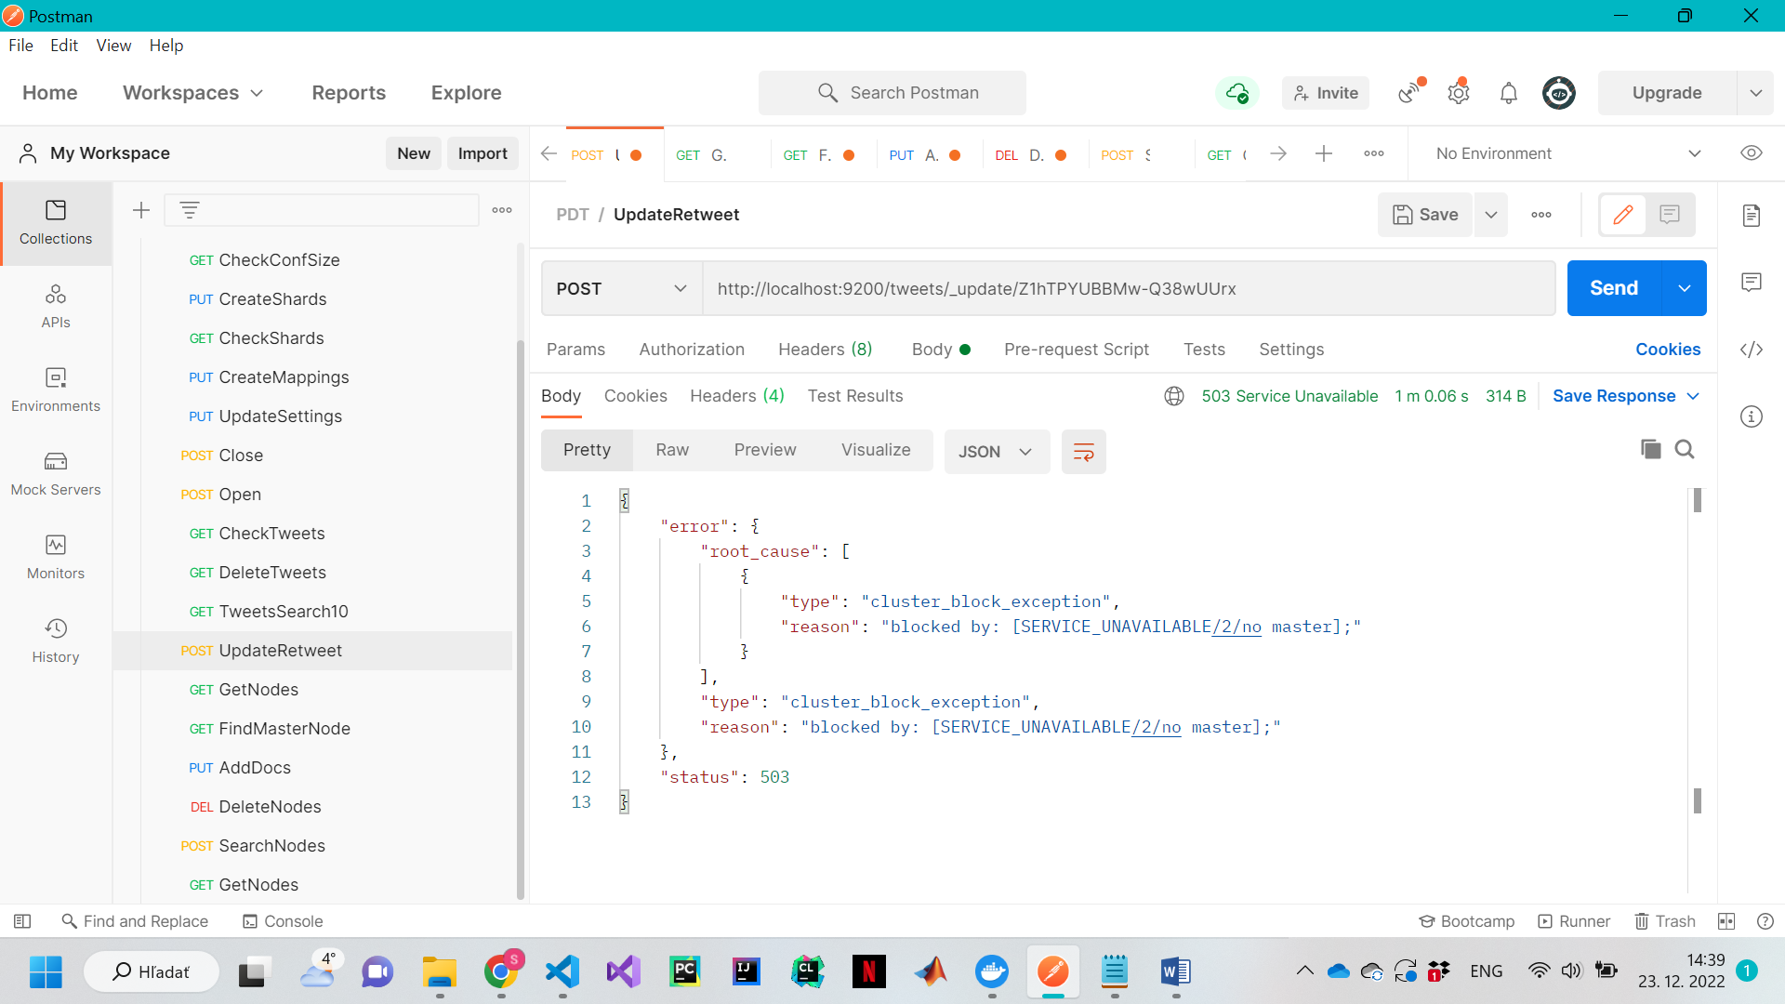

7.

**All nodes:**

PUT -> okay

POST -> okay

GET -> okay

DELETE -> okay

**Es03, es02:**

No LISTENER no http requests

**Es03, es01:**

PUT -> Okay

POST -> Okay

GET -> Okay

DELETE -> Okay

**Es02, es01:**

PUT -> Okay

POST -> Okay

GET -> Okay

DELETE -> Okay

**Es03:**

No LISTENER no http requests

**es02:**

No LISTENER no http requests

**es01:**

PUT -> no Master

POST -> Okay

GET -> Okay

DELETE -> no Master

